**Brighten your future.**

Get your Microsoft Office Specialist certification for **FREE**

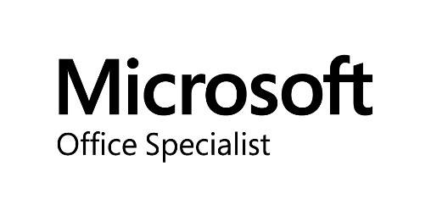

Learn more about Microsoft Office Specialist Certification at:

[**http://prodigylearning.com/academic/mos**](http://prodigylearning.com/academic/mos)

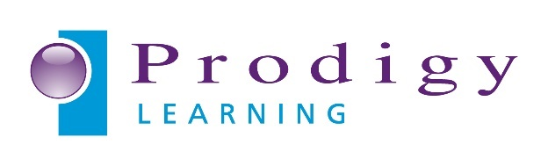

**What’s in it for me?**

A Test**Fest** event provides you with the opportunity to take and potentially earn an industry recognised certification that same day!

It’s also a great opportunity for you to understand what to expect when you participate in a Microsoft Office Specialist (MOS) class.

Earning a MOS credential helps you prove your knowledge and skills as well as contributes to your employability.

**Register today 🡲**

**Register:**

Test**Fest date & time:**

Test**Fest location:**

**For more information:**

Sign up

to attend your local

Test**Fest**



Click or tap here to enter the way you wish students to register e.g. email address

Click or tap here to enter the details of the date and time of your Test**Fest**.

Click or tap here to enter the details of the location on the Test**Fest**

Click or tap here to enter the email address or phone number you wish students to use